1. INTRODUCTION

1.1 Project Overview
BookNest is a modern, full-stack online book store application developed using the MERN stack – MongoDB, Express.js, React.js, and Node.js. It is designed to serve as a digital marketplace connecting readers, independent book sellers, and administrators through a centralized platform.
The platform supports role-based access and includes distinct dashboards for:
- Users (Customers): To browse, search, and purchase books.
- Sellers: To list books, manage inventory, and fulfill orders.
- Admins: To oversee system activities, user management, and content moderation.
BookNest allows users to:
- Explore books by genre, author, or title
- Add books to a cart and place orders
- Leave feedback or ratings
- View their order history
Sellers are empowered to:
- Register and manage their own inventory
- Update stock availability
- View and fulfill orders
Admins can:
- Manage user accounts and seller access
- View overall platform activity
- Ensure policy and content compliance
The application is hosted using Vercel (frontend) and Render (backend) with a cloud-hosted MongoDB Atlas database. Image handling (for book covers) is integrated via Cloudinary, and user authentication is managed using JWT tokens and bcrypt for secure sessions.

1.2 Purpose
The primary purpose of BookNest is to simplify and enhance the online book shopping experience for users while supporting small and independent book sellers in reaching a broader audience without needing technical expertise or third-party e-commerce platforms.
Key objectives include:
- Providing a seamless and intuitive interface for discovering and purchasing books.
- Offering sellers a low-cost, customizable alternative to commercial platforms like Amazon.
- Giving administrators a comprehensive overview to manage and scale the platform securely.
BookNest not only promotes literacy and reading accessibility but also aims to support local book ecosystems and self-publishing authors, thereby contributing to both social value and digital commerce innovation.
2. IDEATION PHASE

2.1 Problem Statement
A significant portion of readers prefer browsing and buying books online for convenience, yet many struggle to find platforms that offer affordable pricing, genuine reviews, and a personalized shopping experience. Simultaneously, independent and small-scale book sellers find it difficult to compete with large retailers due to high platform fees, limited visibility, and lack of control over inventory.
There is a clear gap between readers looking for a diverse, user-friendly book marketplace and sellers seeking a fair, scalable platform to showcase and manage their inventory.
Customer Problem Statement Format
I am an avid reader who wants to explore and buy books online.
I’m trying to find a wide variety of books at reasonable prices.
But most platforms prioritize commercial publishers and lack customization.
Because they are driven by algorithms that favor big sellers and popular titles.
Which makes me feel frustrated and disengaged.
I am a small-scale book seller trying to reach customers online.
I’m trying to list, manage, and sell books easily.
But existing platforms are either too costly or too restrictive.
Because I lack technical knowledge and marketing tools.
Which makes me feel limited and overlooked.

2.2 Empathy Map Canvas
This empathy map captures the mindset and experience of a BookNest user (Reader) to better design a user-centric solution:
Thinks | Feels
“Is this the right platform for me?” | Curious, but overwhelmed by choices
“Are the books genuine and fairly priced?” | Frustrated with too many ads or irrelevant suggestions
Says |  | Hears
“I want books from independent authors too.” |  | “Try Amazon or Flipkart.”
“I wish this was more personalized.” |  | “That site doesn't have many niche titles.”

Sees | Does
Crowded interfaces, paid promotions | Compares prices across sites
Too much focus on mainstream books | Abandons cart if delivery is slow or confusing
A similar empathy map can be created for sellers and admins to ensure complete user coverage in the solution design.

2.3 Brainstorming
Brainstorming Objective:
To generate a wide range of feature ideas and pain point solutions that will make BookNest both user-friendly and commercially viable.
Raw Ideas Generated:
- Personalized book recommendations
- Seller dashboard for inventory and order management
- Review and rating system
- Social login (Google, LinkedIn)
- Cart and order tracking
- Book donation/exchange option
- Real-time stock updates
- Admin panel with usage analytics
Prioritization Matrix:
Idea | Impact | Effort | Priority
Google Login | High | Low | High
Seller Book Listing | High | Medium | High
Personalized Recommendations | High | High | Medium
Book Ratings & Reviews | High | Medium | High
Admin Management Panel | Medium | Medium | Medium
Book Donation Section | Medium | High | Low
Shortlisted for MVP (Minimum Viable Product):
- User authentication (Email + Google)
- Book browsing and search
- Cart and checkout functionality
- Seller dashboard for book listing
- Feedback system
- Admin dashboard for monitoring
These selected ideas balance technical feasibility and user impact and form the foundation for future sprints.
3. REQUIREMENT ANALYSIS

3.1 Customer Journey Map
The customer journey map visualizes the experience of a BookNest user (Reader) from discovering the platform to completing a book purchase:
Stage | Customer Action | Touchpoints | Pain Points | Opportunities
Awareness | Learns about BookNest via social media/search | Website, SEO, Social Media | Limited initial trust | Highlight seller credibility and user ratings
Exploration | Browses books by genre or search bar | Homepage, Search, Filters | Overwhelmed by options | Add personalized recommendations
Consideration | Reads book details, reviews, price comparison | Book Detail Page, Reviews | Unsure about book quality or seller | Add seller badges, verified reviews
Purchase | Adds to cart and checks out | Cart, Checkout, Payment Gateway | Friction in payment flow | Implement trusted payment and smooth UI
Post-purchase | Receives order confirmation, leaves feedback | Email, Dashboard, Order History | No incentives to return | Recommend similar books, offer loyalty perks
A similar journey map can be developed for Sellers and Admins to ensure all roles are addressed.

3.2 Solution Requirement
3.2.1 Functional Requirements (FR)
FR No. | Functional Requirement (Epic) | Sub-Tasks / Stories
FR-1 | User Registration & Authentication | Register via Email, Google
FR-2 | Book Browsing | Filter/search by genre, author, title
FR-3 | Cart & Order Placement | Add to cart, update cart, place order
FR-4 | Feedback System | Add/view ratings & reviews
FR-5 | Seller Dashboard | Add/edit/delete books, view orders
FR-6 | Admin Controls | Manage users, sellers, and books
3.2.2 Non-Functional Requirements (NFR)
NFR No. | Non-Functional Requirement | Description
NFR-1 | Usability | Intuitive UI, responsive design
NFR-2 | Security | JWT-based auth, bcrypt password hashing, input validation
NFR-3 | Reliability | Stable data handling, fail-safe error management
NFR-4 | Performance | Fast load times, optimized API calls, CDN usage
NFR-5 | Availability | Deployed on cloud with near-100% uptime
NFR-6 | Scalability | Modular backend with MongoDB Atlas, deployable across cloud infrastructure

3.3 Data Flow Diagram (DFD)
Level 1 DFD – Detailed Functional Breakdown
- User
  - Registers/Login → Auth API → JWT Token
  - Browses/Searches → Book API → Book List
  - Places Order → Order API → Order Stored
  - Leaves Feedback → Feedback API → Stored
- Seller
  - Logs In → Auth API
  - Adds Books → Book API → Stored in MongoDB
  - Views Orders → Order API → Returns Book Orders
- Admin
  - Access Dashboard → Admin API → Returns Users/Sellers
  - Manages Books/Users → Delete/Edit via Admin Routes

3.4 Technology Stack
Component | Technology Used | Description
Frontend | React.js, HTML5, CSS3, Bootstrap | User interface for all roles with dynamic routing
Backend | Node.js, Express.js | Handles APIs, authentication, and business logic
Database | MongoDB Atlas | NoSQL database for storing users, books, orders, reviews
Version Control | Git & GitHub | Team collaboration and source code versioning

4. PROJECT DESIGN

4.1 Problem-Solution Fit
The core problem identified is the lack of an affordable, intuitive, and supportive platform for both book readers and independent book sellers. Most existing platforms prioritize large-scale publishers or sellers, leaving smaller sellers with little visibility and limited tools. On the other hand, users experience frustration due to limited personalized discovery, lack of transparency in reviews, and generic user experiences.
BookNest provides a direct solution to this gap by offering:
- A user-friendly marketplace for discovering and purchasing books
- An accessible platform for independent sellers to list and manage inventory
- A scalable admin system to monitor platform health and enforce quality control
This alignment between user needs and technical capabilities confirms the problem-solution fit.

4.2 Proposed Solution
BookNest is designed as a full-stack, role-based book marketplace that solves the identified challenges through a clean, modular, and scalable web platform.
Key Features:
- User Features:
  - Register and login using email or Google
  - Browse books by genre, author, or search query
  - Add books to cart and complete orders
  - Leave feedback and star ratings
- Seller Features:
  - Secure login and registration
  - Dashboard to add, edit, or delete books
  - Manage inventory and view customer orders
- Admin Features:
  - View and manage registered users and sellers
  - Delete inappropriate content or spam entries
  - Monitor order activity and overall platform health
Additional Functional Highlights:
- Passwords are encrypted using bcrypt
- Authentication is powered by JWT tokens
- Fully responsive frontend built with React.js and styled using Bootstrap
The platform adheres to MVC architecture, ensuring clear separation of concerns and clean code maintainability.

4.3 Solution Architecture
Below is the textual description of your solution architecture. (A diagram can also be included visually.)
Frontend (React.js)
- Communicates with backend through secure RESTful APIs.
- Handles client-side routing using React Router.
- Responsive design ensures usability on mobile and desktop.
Backend (Node.js + Express.js)
- Exposes RESTful APIs for all features (auth, books, orders, feedback).
- Validates and processes requests securely.
- Handles roles and access control (User, Seller, Admin).
Database (MongoDB Atlas)
- Stores user data, book listings, order details, feedback.
- Collections: users, books, orders, feedback, sellers.
Cloud Services
- Vercel hosts the frontend.
- Render hosts the backend server.
- JWT ensures secure and stateless session management.
Admin Layer
- Accessible only by the admin role.
- Enables moderation and system monitoring.
- Provides CRUD capabilities for users, books, and orders.

5. PROJECT PLANNING & SCHEDULING

5.1 Project Planning
The development of BookNest followed an Agile Scrum methodology, broken down into multiple sprints, each lasting approximately 5 to 6 working days. Each sprint focused on delivering a specific set of features (epics), which were broken down into manageable user stories and tasks.

Sprint-Based Product Backlog
Sprint | Functional Requirement (Epic) | User Story No. | User Story / Task | Story Points | Priority | Team Members
Sprint-1 | Registration & Login | USN-1 | As a user, I can register using email and password | 2 | High | [Your Team Members]
 |  | USN-2 | As a user, I will receive a confirmation email after registration | 1 | High
 |  | USN-4 | As a user, I can register through Google | 2 | Medium
 | Login | USN-5 | As a user, I can log in using my credentials | 1 | High
 | Seller Book Upload | USN-6 | As a seller, I can add a book with name, genre, image, and price | 3 | High
Sprint-2 | Book Browsing & Cart | USN-7 | As a user, I can browse and search for books by name, genre, or author | 2 | High
 |  | USN-8 | As a user, I can add books to cart and view cart summary | 2 | High
 | Order Placement | USN-9 | As a user, I can place an order and receive confirmation | 3 | High
Sprint-3 | Admin Management | USN-10 | As an admin, I can view, add, or delete books and users | 4 | Medium
 | Feedback System | USN-11 | As a user, I can leave feedback and rate purchased books | 2 | Medium

6. FUNCTIONAL AND PERFORMANCE TESTING

6.1 Performance Testing
Performance testing ensures the stability, speed, scalability, and responsiveness of the BookNest web application under a particular workload.

Objectives of Performance Testing:
- To evaluate the response time of APIs (e.g., login, book listing, checkout)
- To ensure consistent behavior under concurrent user access
- To verify database and server performance under increasing load
- To eliminate bottlenecks prior to deployment

Performance Metrics Observed:
Metric | Description | Target / Result
API Response Time (Avg.) | Time taken to get a successful response from API | ~120 ms
Page Load Time | Time taken for main page and dashboard to load | < 2 seconds
Book Listing Render Time | Time taken to render and display list of books | ~1.2 seconds
Image Load Time | Time to fetch and render book images from Cloudinary | ~300 ms
Concurrent User Support | Maximum simultaneous users without server crash | 100+ users

7. RESULTS:
7.1 Output Screenshots
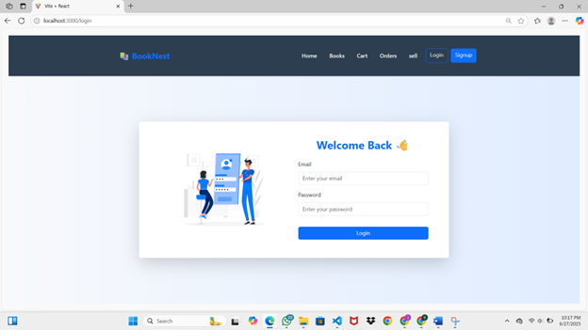

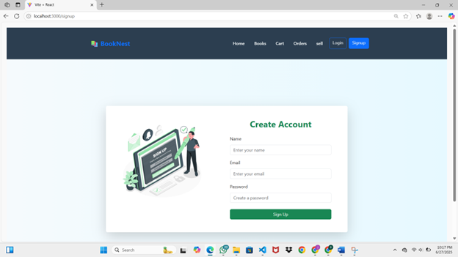

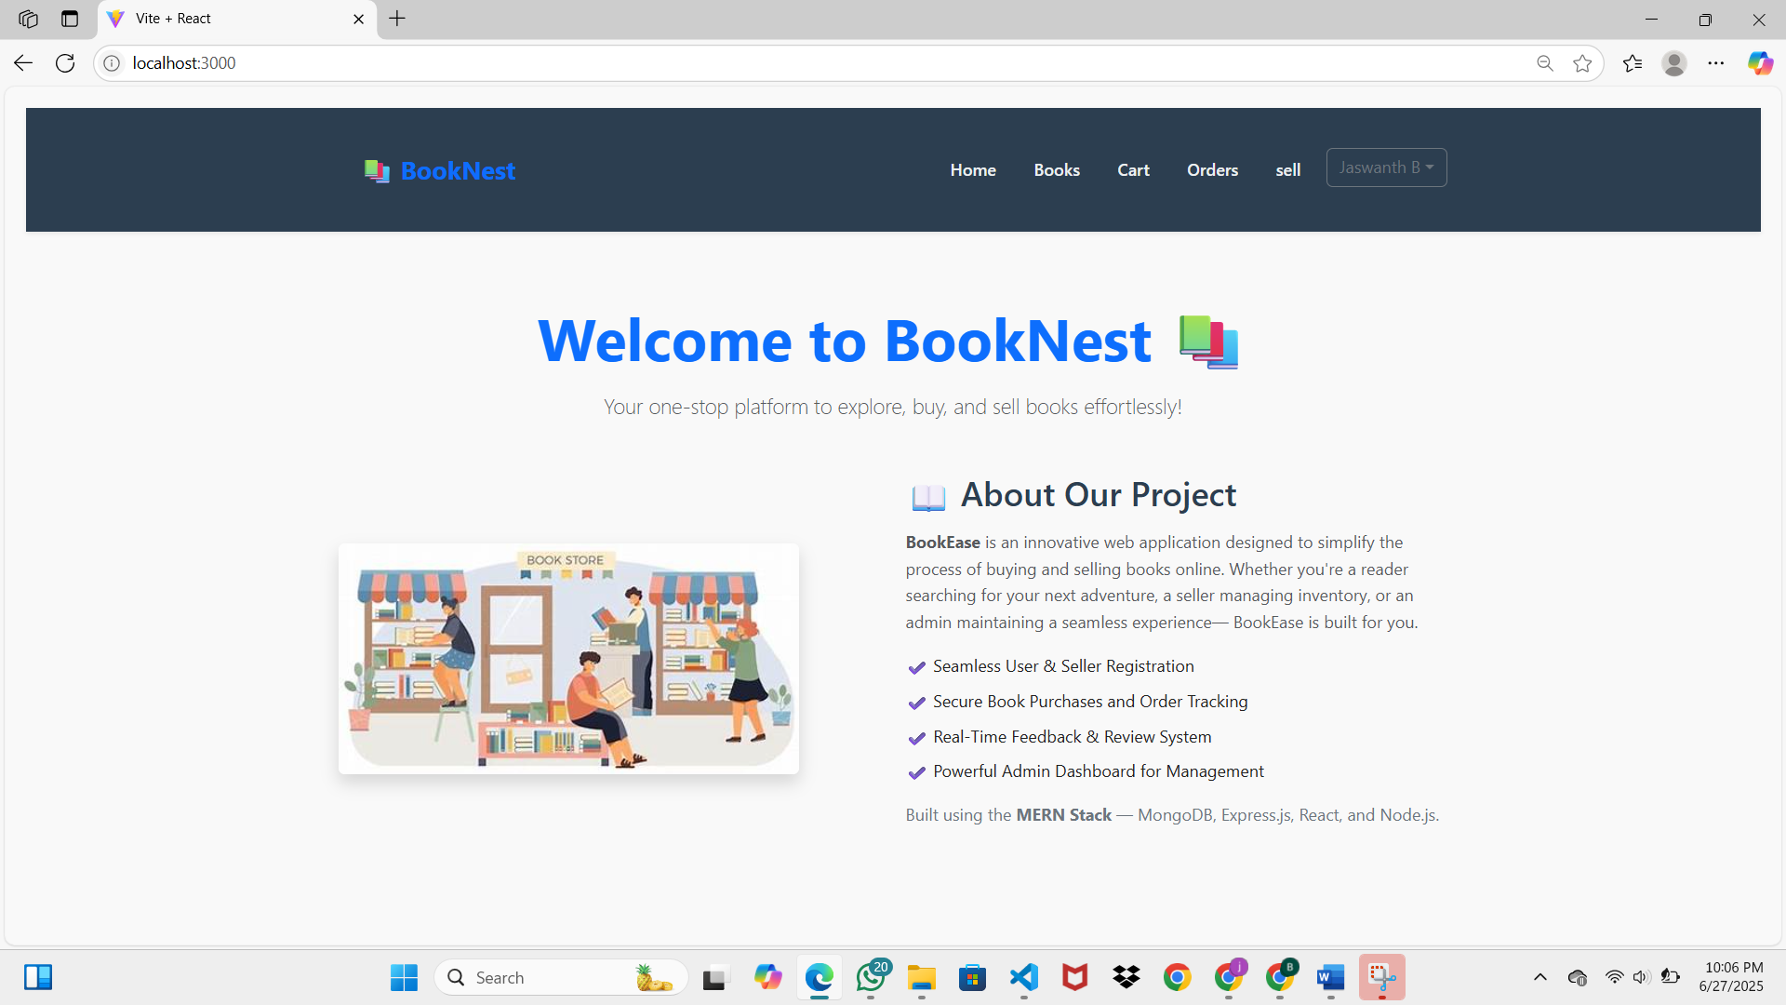
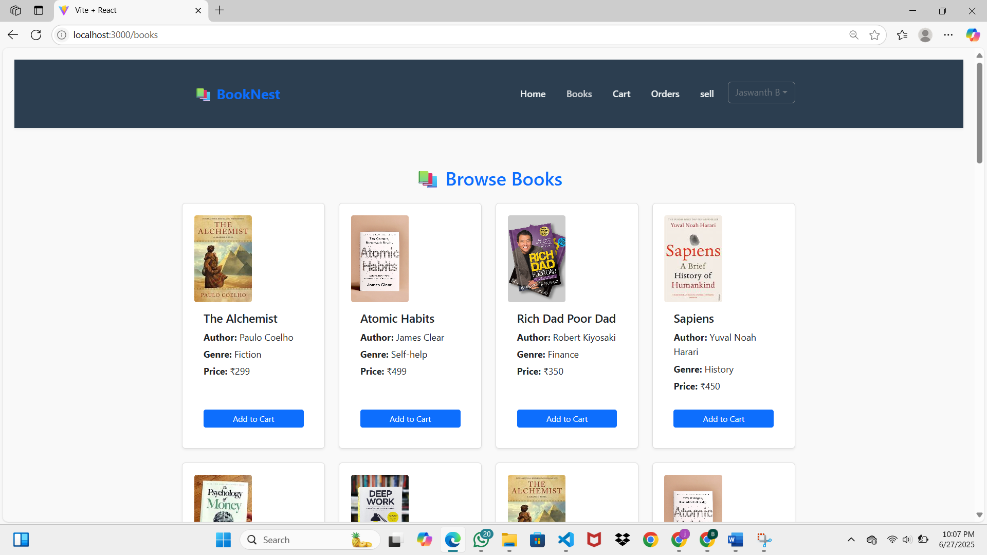
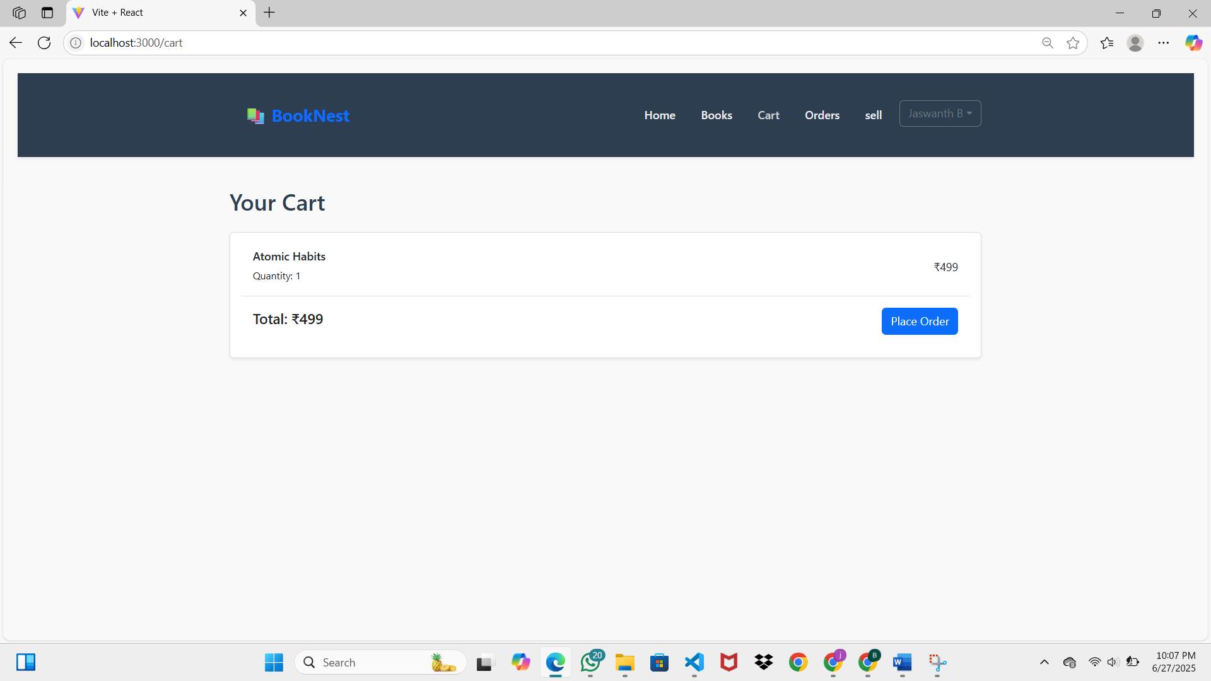
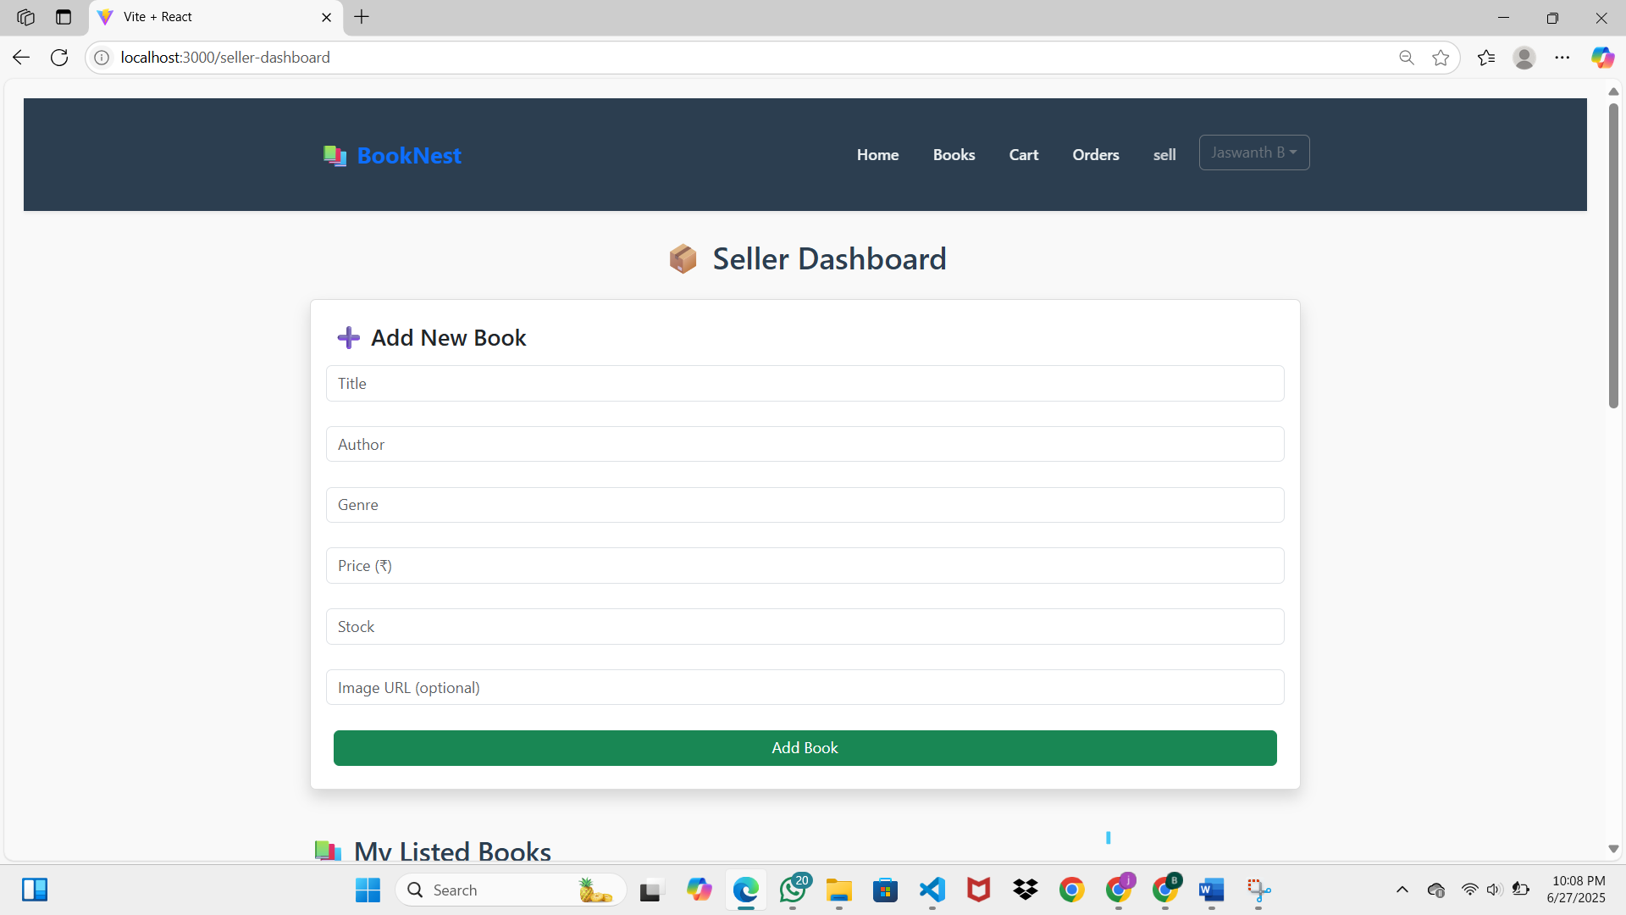

8. ADVANTAGES & DISADVANTAGES

8.1 Advantages
The BookNest application delivers several benefits to different stakeholders — users, sellers, and administrators — through its well-structured and scalable architecture.
For Users (Customers):
- User-Friendly Interface: Intuitive and responsive UI built with React ensures smooth navigation across devices.
- Flexible Search & Filter: Users can easily search books by name, genre, or author.
- Secure Authentication: JWT-based login ensures session safety, while passwords are securely encrypted using bcrypt.
- Feedback System: Users can leave and view ratings/reviews, aiding better decision-making before purchase.
- Order Management: Users can track past orders and view real-time updates.
For Sellers:
- Seller Dashboard: Enables book listing, price setting, and stock management.
- Order Visibility: Sellers can track the orders received on their books.
- Independent Control: Offers autonomy to sellers without reliance on large marketplaces.
For Admins:
- Full Control Panel: Admins can manage users, sellers, books, and monitor all activities.
- Security & Oversight: Admins can take action against suspicious users or inappropriate content.

8.2 Disadvantages / Limitations
While the current MVP of BookNest fulfills most core functionalities, some limitations are noted that can be improved in future iterations:
Limitations:
- Basic Recommendation Engine: Personalized recommendations are not yet implemented — could enhance UX.
- No Chat Support or Notifications: Real-time features such as seller-buyer chat or push notifications are currently absent.
- Limited Admin Analytics: The admin dashboard lacks advanced visual analytics for trends, usage stats, etc.
- No Mobile App: The current system is web-only. A mobile app could further improve accessibility.

9. CONCLUSION
- The BookNest platform has been successfully developed as a scalable, full-stack web application that addresses the core needs of book readers, independent sellers, and administrators. With clear role-based access, secure authentication, and user-friendly interfaces, the system ensures a seamless experience across all modules.
- The project was built using modern technologies such as React.js, Node.js, MongoDB, and JWT, and follows best practices in design, development, and testing. All core functionalities were implemented and tested within the planned sprints, achieving the goals set during the planning phase.
- This implementation serves as a strong foundation for real-world deployment and future enhancements, aligning both technical performance and user satisfaction.
10. FUTURE SCOPE
The BookNest platform can be further enhanced with additional features and integrations to improve user experience, scalability, and market competitiveness. The following are the key areas identified for future development:
- • Integration of a Personalized Recommendation System based on user preferences and reading history.
• Implementation of a secure and seamless Payment Gateway (e.g., Razorpay, Stripe) for real-time transactions.
• Development of a dedicated Mobile Application for both Android and iOS platforms to improve accessibility.
• Addition of Real-Time Chat functionality between users and sellers for direct communication.
• Enhancement of the Admin Dashboard with graphical analytics and user behavior insights.
• Integration of Push Notifications and Email Alerts for order updates and promotions.
• Multi-language support to cater to a wider audience.
• Role-based access expansion to support publishers and delivery agents in the future.
11. APPENDIX:
Git:
https://github.com/B-jaswanth2004/BookNest-Where-Stories-Nestle.git
YouTube:
https://youtu.be/jH5wub5ER9Q

